**Ticket Booking System**

**TASK-1**

**1. Create the database named "TicketBookingSystem".**

create database TicketBookingSystem

use TicketBookingSystem

**2. Write SQL scripts to create the mentioned tables**

--To create Venue table

create table tbl_venue (

venue_id int primary key,

venue_name varchar(100),

address varchar(100)

);

--To create Event table

create table tbl_event (

event_id int primary key,

event_name varchar(100),

event_date date,

event_time time,

venue_id int foreign key references tbl_venue(venue_id),

total_seats int,

available_seats int,

ticket_price decimal(10,2),

event_type varchar(50) check (event_type in ('movie', 'sports', 'concert'))

);

--To create Customer table

create table tbl_customer (

customer_id int primary key,

customer_name varchar(50),

email varchar(50),

phone_number varchar(20)

)

--To create Booking table

create table tbl_booking (

booking_id int primary key,

customer_id int foreign key references tbl_customer(customer_id),

event_id int foreign key references tbl_event(event_id),

num_tickets int,

total_cost decimal(10,2),

booking_date date

);

**3. Create an ERD (Entity Relationship Diagram) for the database.**

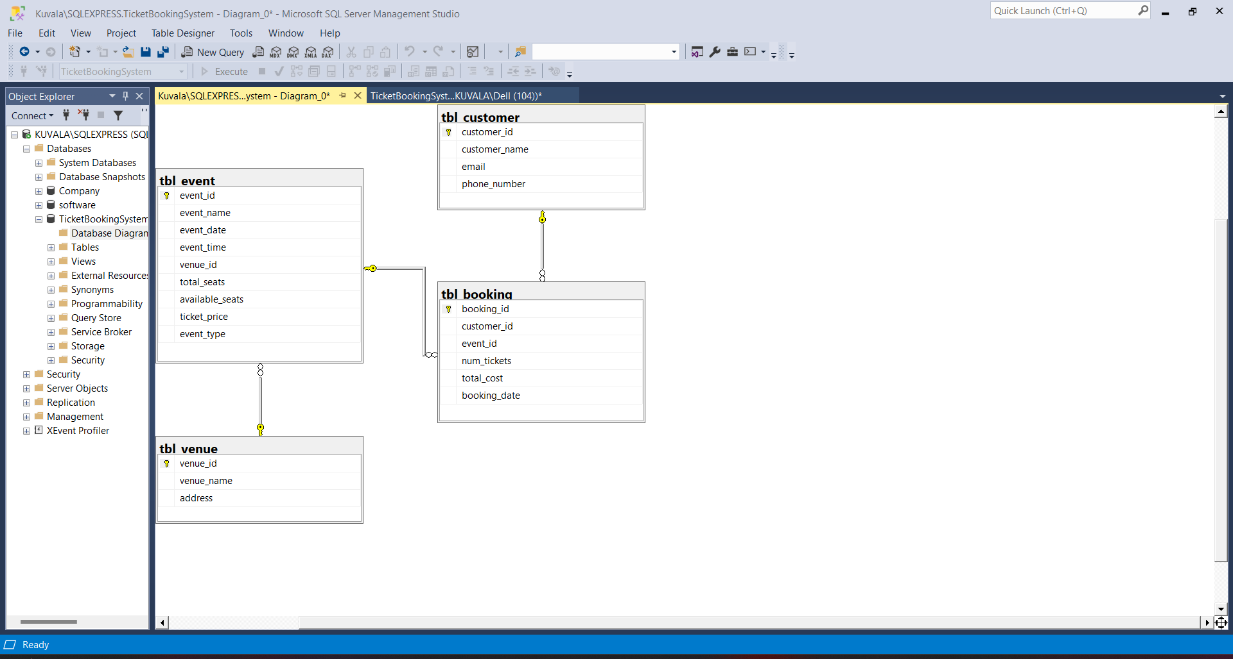

**4. Create appropriate Primary Key and Foreign Key constraints for referential integrity.**

alter table tbl_event

add constraint fk_event_venue

foreign key (venue_id) references tbl_venue(venue_id);

alter table tbl_event

add constraint fk_event_booking

foreign key (booking_id) references tbl_booking(booking_id);

alter table tbl_customer

add constraint fk_customer_booking

foreign key (booking_id) references tbl_booking(booking_id);

alter table tbl_booking

add constraint fk_booking_customer

foreign key (customer_id) references tbl_customer(customer_id);

alter table tbl_booking

add constraint fk_booking_event

foreign key (event_id) references tbl_event(event_id);

**TASK-2**

**Q1.Write a SQL query to insert at least 10 sample records into each table.**

**--Venue table**

insert into tbl_venue (venue_id, venue_name, address) values

(1, 'City Hall', 'MG Road, Bengaluru'),

(2, 'Grand Arena', 'Marine Drive, Mumbai'),

(3, 'Sunset Park', 'Gachibowli, Hyderabad'),

(4, 'Ocean Center', 'RK Beach, Visakhapatnam'),

(5, 'Green Garden', 'Lodhi Road, New Delhi'),

(6, 'Tech Hub', 'Hinjewadi, Pune'),

(7, 'Royal Theatre', 'Park Street, Kolkata'),

(8, 'Sky Dome', 'Anna Salai, Chennai'),

(9, 'Cultural Center', 'Sector 17, Chandigarh'),

(10, 'Mega Grounds', 'Bistupur, Jamshedpur');

**--Event table**

insert into tbl_event (event_id, event_name, event_date, event_time, venue_id, total_seats, available_seats, ticket_price, event_type) values

(101, 'Rock Concert', '2025-04-10', '18:00', 2, 500, 300, 50.00, 'Concert'),

(102, 'Football Match', '2025-05-01', '16:00', 10, 1000, 800, 75.00, 'Sports'),

(103, 'Movie Night', '2025-03-25', '20:00', 1, 200, 150, 15.00, 'Movie'),

(104, 'Drama Play', '2025-04-15', '19:00', 7, 300, 100, 25.00, 'Concert'),

(105, 'Cricket Match', '2025-06-05', '14:00', 10, 1500, 1000, 80.00, 'Sports'),

(106, 'Jazz Night', '2025-04-20', '21:00', 4, 250, 50, 40.00, 'Concert'),

(107, 'Tech Expo', '2025-05-15', '10:00', 6, 600, 400, 20.00, 'Concert'),

(108, 'Indie Film', '2025-03-30', '18:30', 1, 150, 50, 12.00, 'Movie'),

(109, 'Basketball Game', '2025-04-22', '17:00', 10, 900, 600, 70.00, 'Sports'),

(110, 'Cultural Show', '2025-05-10', '19:30', 9, 400, 300, 30.00, 'Concert');

**--Customer table**

insert into tbl_customer (customer_id, customer_name, email, phone_number) VALUES

(1, 'Dharshini', 'dharshini@gmail.com', '6655443322'),

(2, 'Akshay', 'akshay@gmail.com', '8765432109'),

(3, 'Naveen', 'naveen@gmail.com', '6543210987'),

(4, 'Priya', 'priya@gmail.com', '7432109876'),

(5, 'Dhanashree', 'dhanashree@gmail.com', '7321098765'),

(6, 'Sharon Benny', 'sharon@gmail.com', '7210987654'),

(7, 'Karnika', 'karnika@gmail.com', '0109876543'),

(8, 'Abdhul', 'abdhul@gmail.com', '9098765432'),

(9, 'Nilofur', 'nilofur@gmail.com', '9988776655'),

(10, 'Dheva', 'dheva@gmail.com', '8877665544');

**--Booking table**

insert into tbl_booking (booking_id, customer_id, event_id, num_tickets, total_cost, booking_date) values

(201, 1, 101, 2, 100.00, '2025-03-01'),

(202, 2, 102, 4, 300.00, '2025-03-05'),

(203, 3, 103, 3, 45.00, '2025-03-10'),

(204, 4, 104, 2, 50.00, '2025-03-12'),

(205, 5, 105, 5, 400.00, '2025-03-15'),

(206, 6, 106, 1, 40.00, '2025-03-18'),

(207, 7, 107, 2, 40.00, '2025-03-20'),

(208, 8, 108, 4, 48.00, '2025-03-22'),

(209, 9, 109, 3, 210.00, '2025-03-24'),

(210, 10, 110, 2, 60.00, '2025-03-26');

**2.Write a SQL query to list all Events.**

**select * from tbl_event**

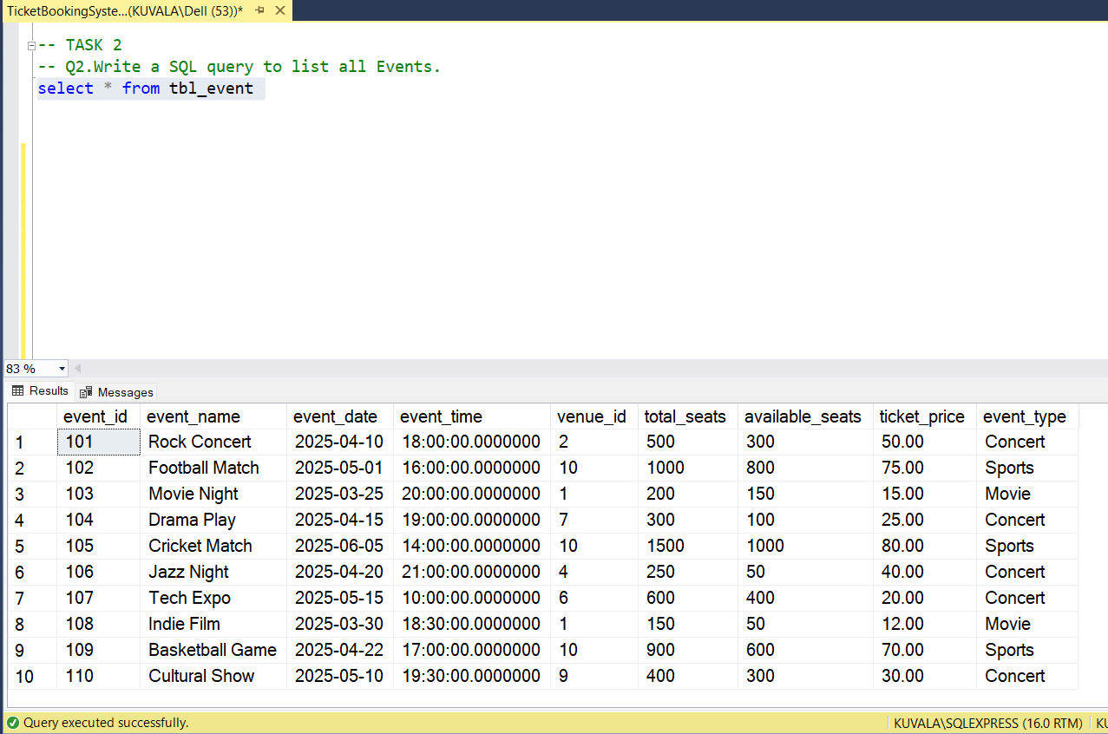

**3.Write a SQL query to select events with available tickets.**

**select * from tbl_event where available_seats > 0**

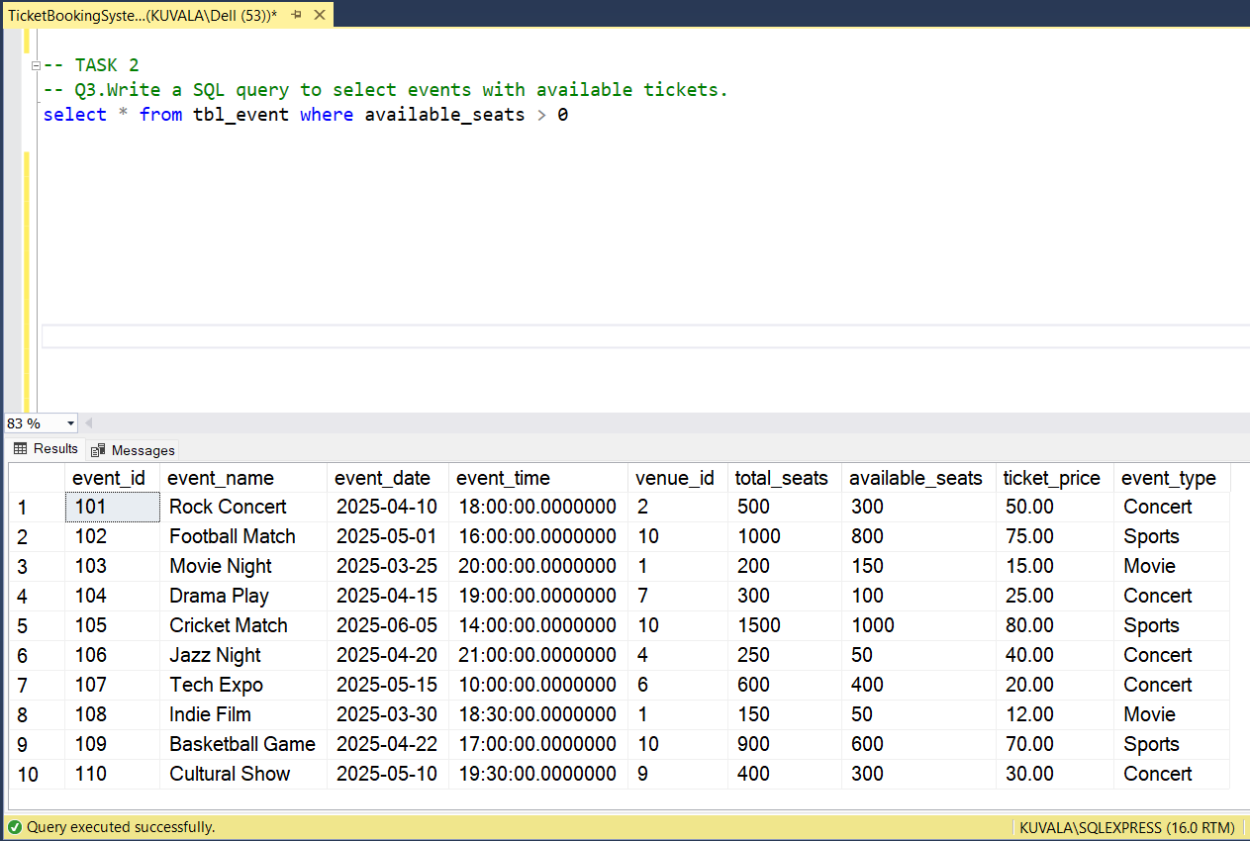

**4.Write a SQL query to select events name partial match with ‘cup’.**

**select * from tbl_event where event_name like '%cup%'**

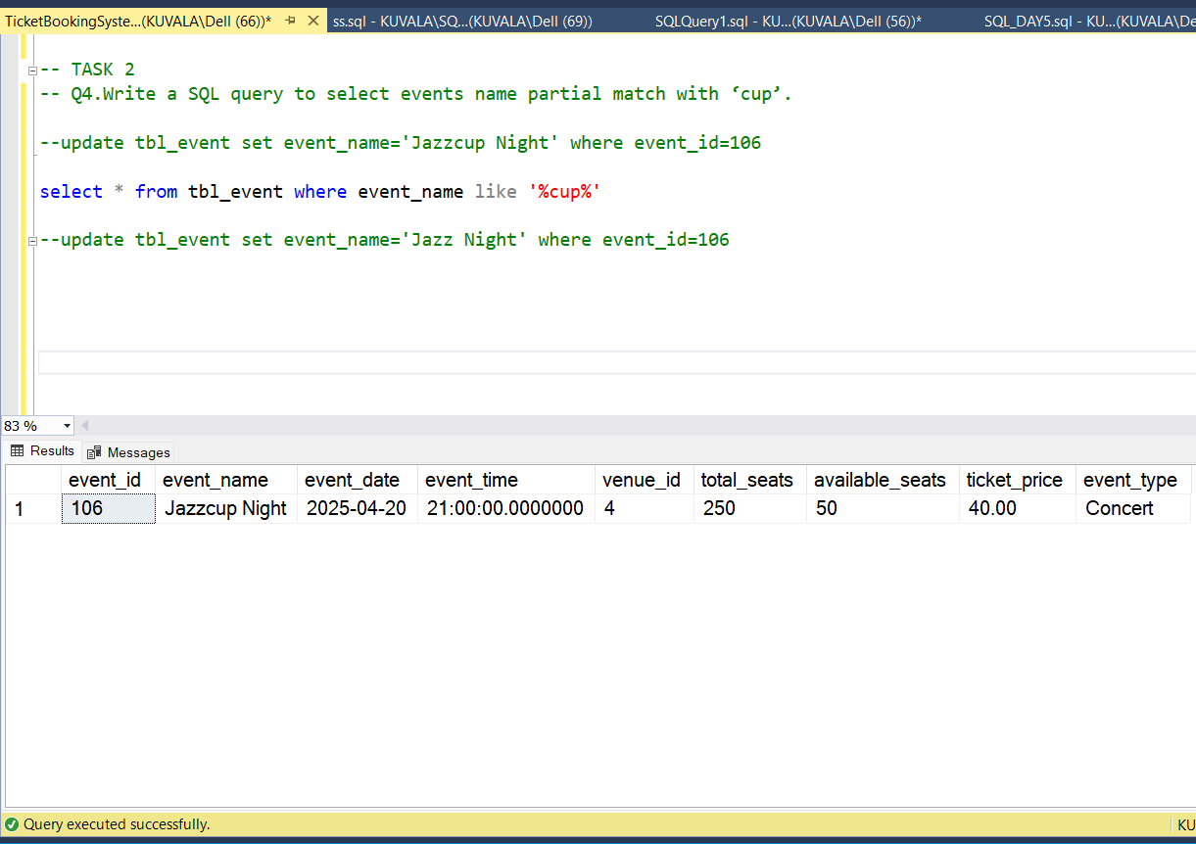

**5. Write a SQL query to select events with ticket price range is between 1000 to 2500.**

**select * from tbl_event where ticket_price between 1000 and 2500**

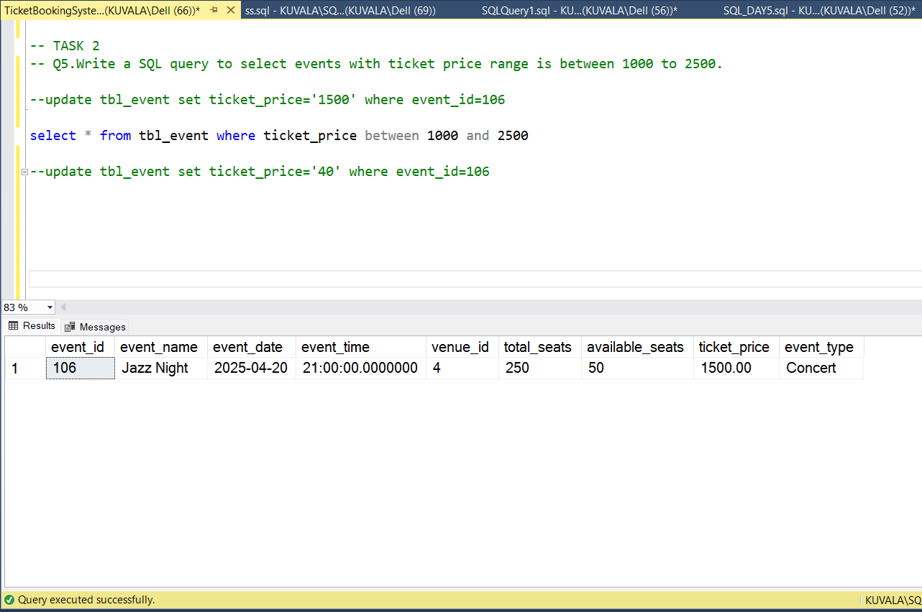

**6. Write a SQL query to retrieve events with dates falling within a specific range.**

**select* from tbl_event where event_date between '2025-04-10' and '2025-04-20'**

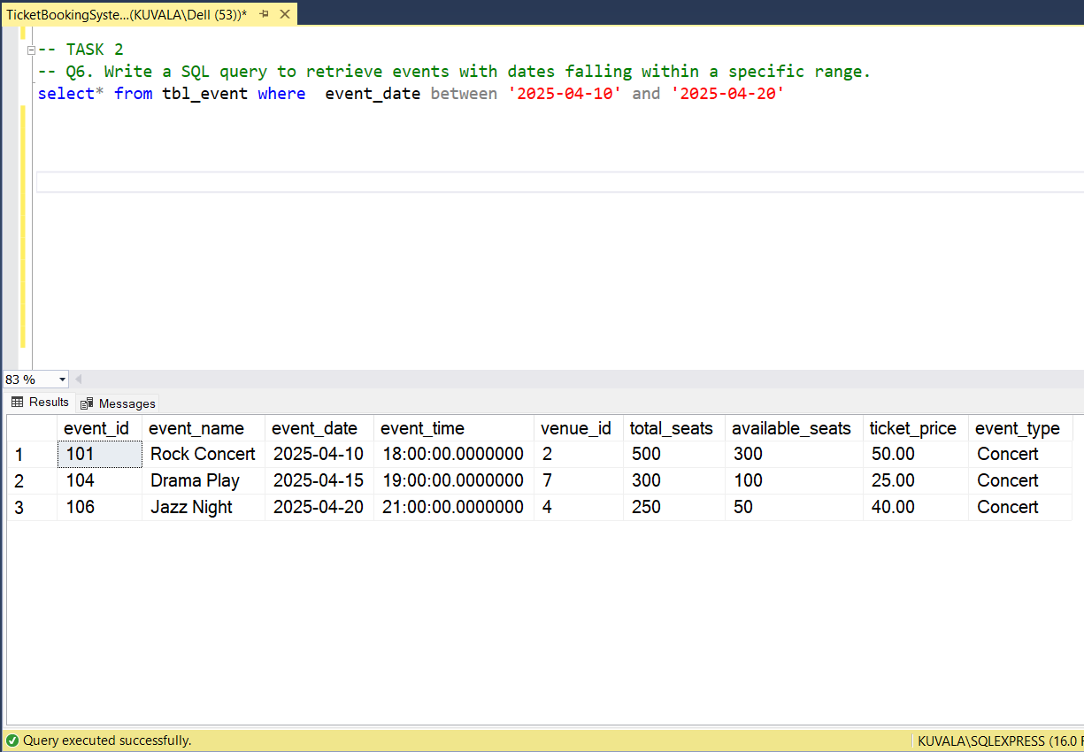

**7. Write a SQL query to retrieve events with available tickets that also have "Concert" in their name.**

**select * from tbl_event where available_seats>0 and event_name like '%Concert%'**

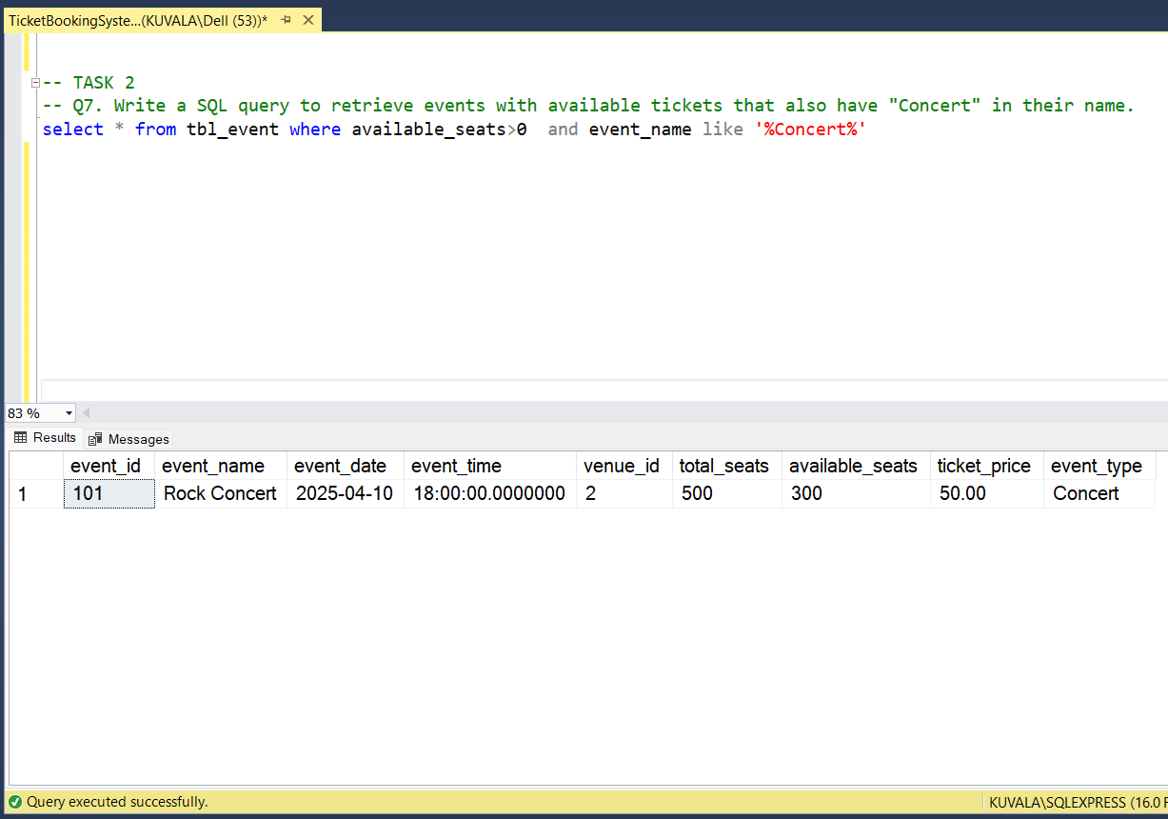

**8.Write a SQL query to retrieve users in batches of 5, starting from the 6th user.**

**select * from tbl_customer order by customer_id**

**offset 5 rows fetch next 5 rows only**

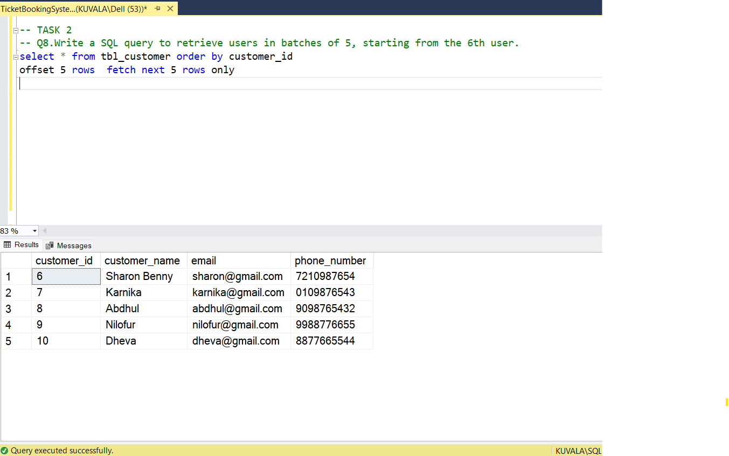

**9. Write a SQL query to retrieve bookings details contains booked no of ticket more than 4.**

**select * from tbl_booking where num_tickets>4**

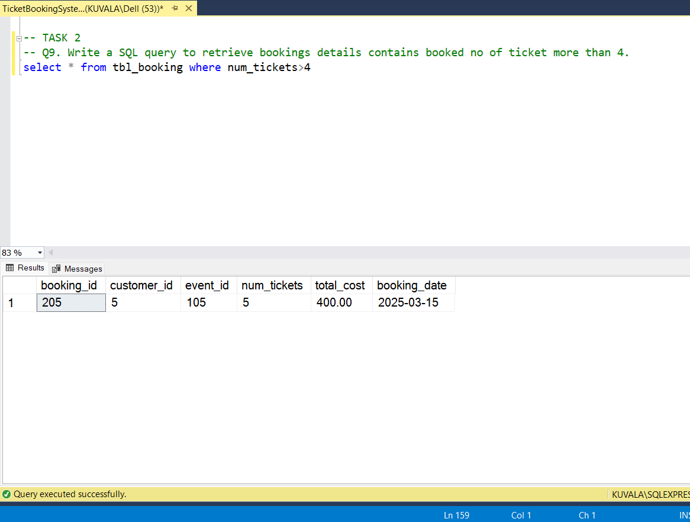

**10.Write a SQL query to retrieve customer information whose phone number end with ‘000’ .**

**select * from tbl_customer where phone_number like '%000'**

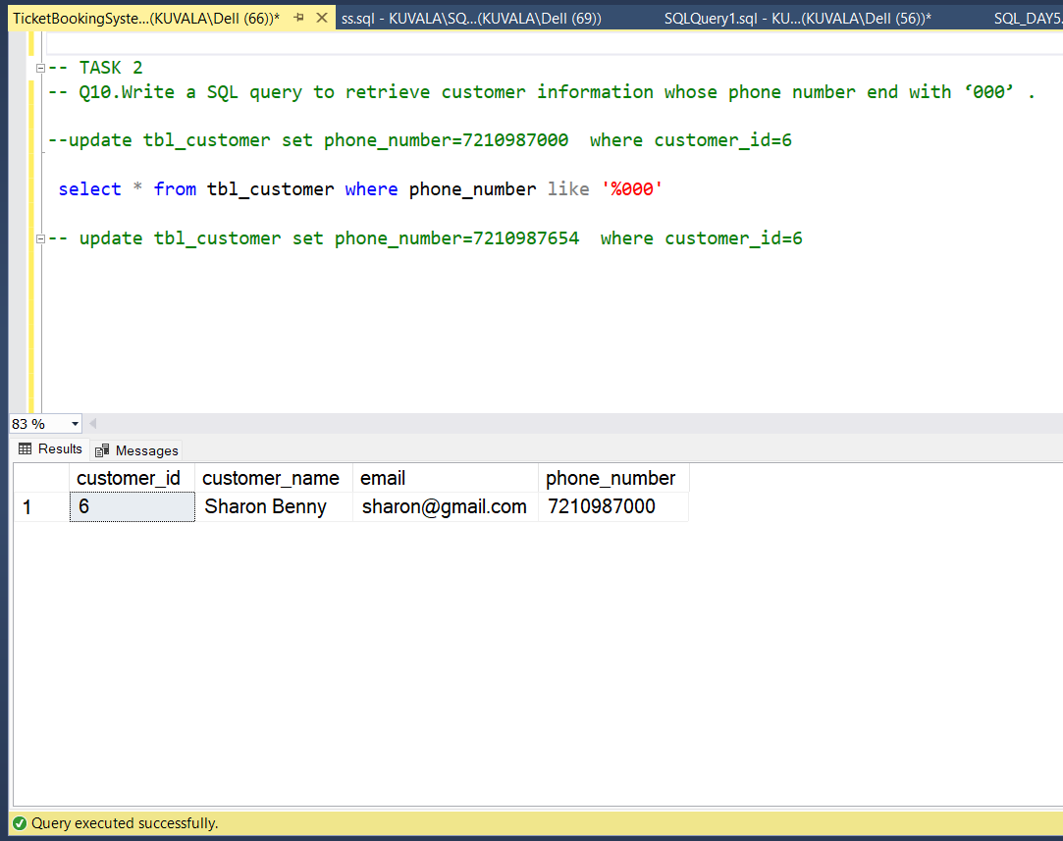

**11..Write a SQL query to retrieve the events in order whose seat capacity more than 15000.**

**select * from tbl_event where total_seats>15000**

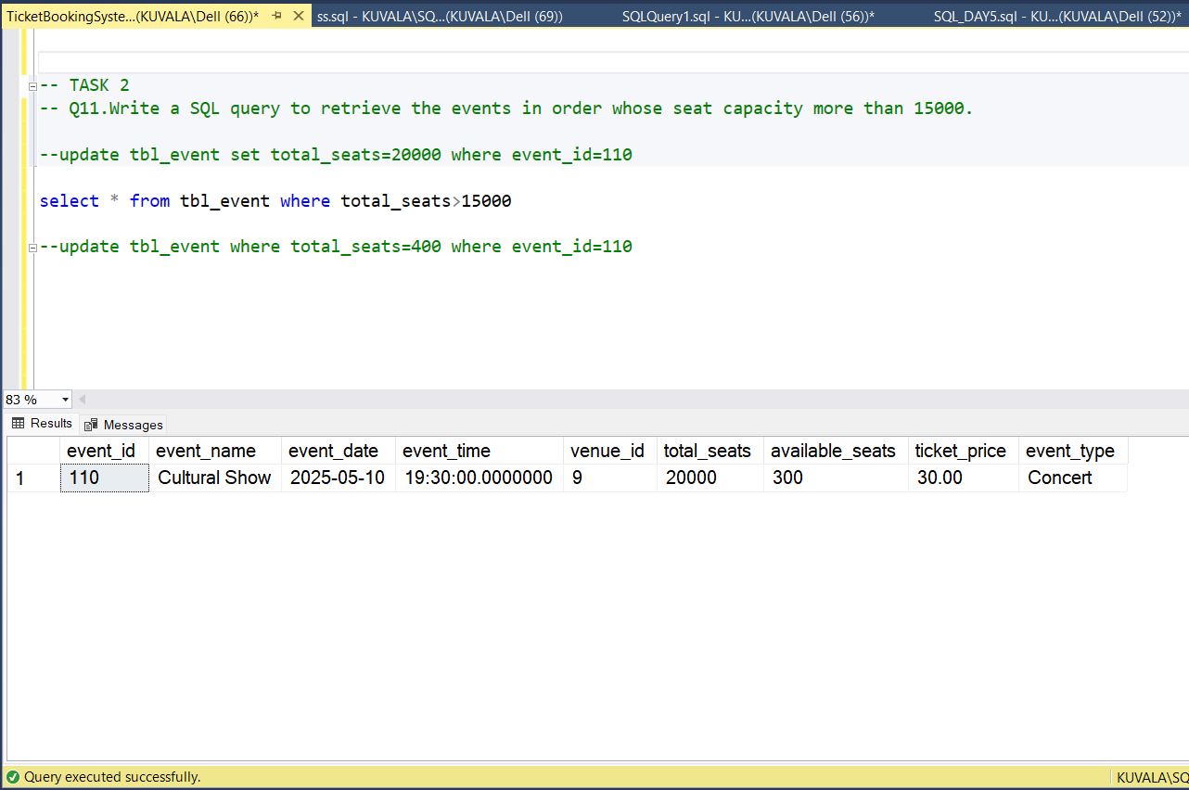

**12.Write a SQL query to select events name not start with ‘x’, ‘y’, ‘z’.**

**select * from tbl_event where event_name not like 'x%' and event_name not like 'y%' and**

**event_name not like 'z%'**

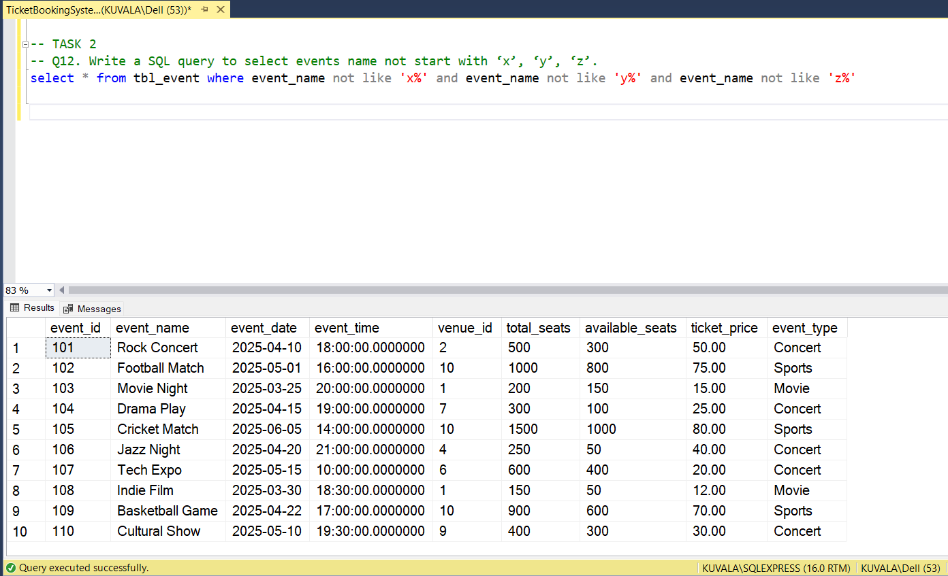

**TASK-3**

**1. Write a SQL query to List Events and Their Average Ticket Prices.**

**select event_name as "Event Name" ,avg(available_seats) as "Average Ticket Price"**

**from tbl_event**

**group by event_name**

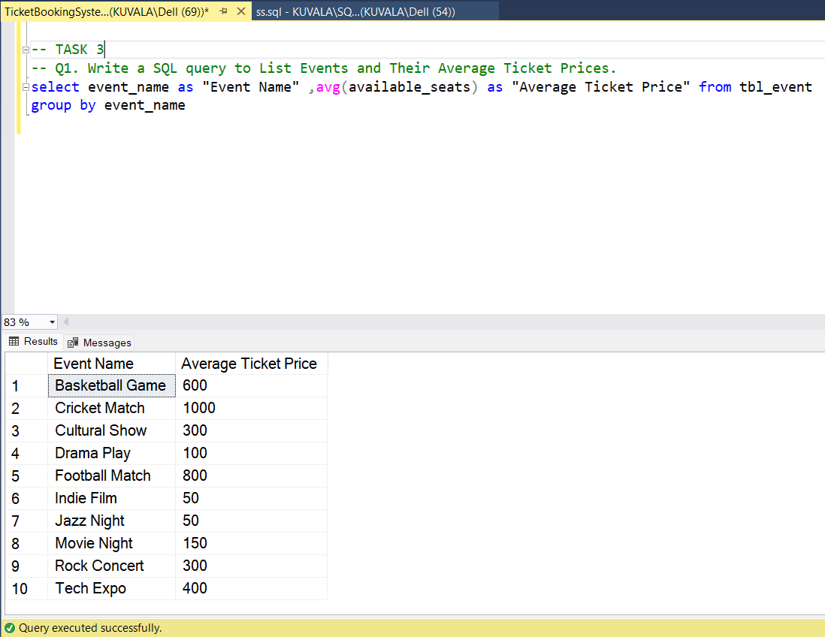

**2.Write a SQL query to Calculate the Total Revenue Generated by Events.**

**select e.event_name,sum(b.total_cost) as "Total cost" from tbl_event e**

**join tbl_booking b on b.event_id=e.event_id**

**group by e.event_name**

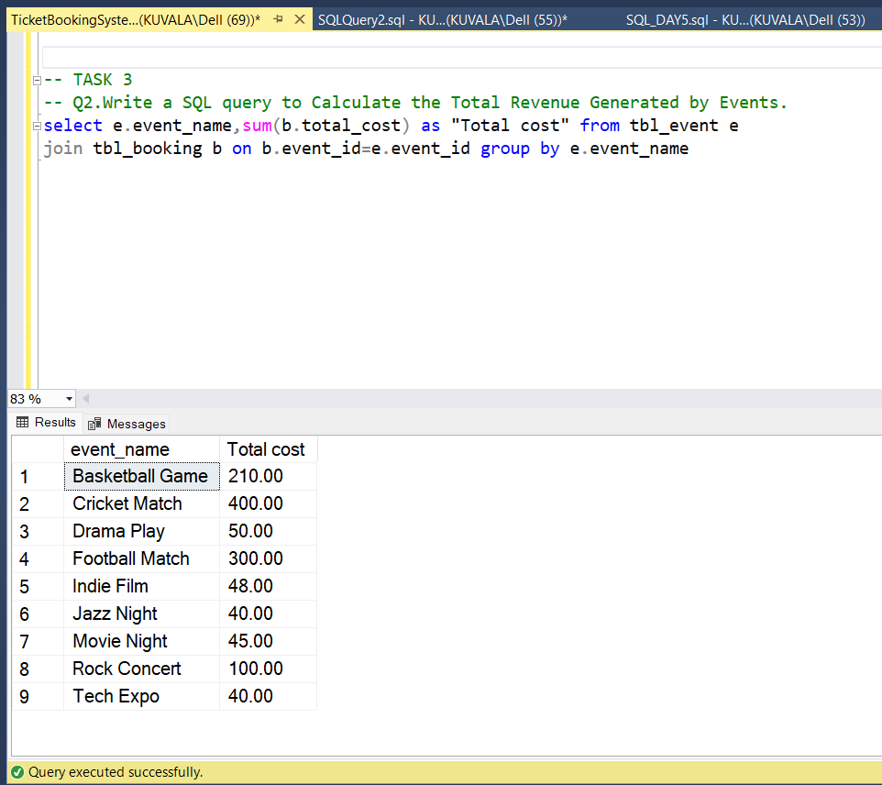

**3.Write a SQL query to find the event with the highest ticket sales.**

**select top 1 b.event_id,e.event_name,sum(b.total_cost) as Hightest_ticket_sales from tbl_booking b**

**join tbl_event e on e.event_id=b.event_id group by b.event_id,e.event_name,b.event_id**

**order by Hightest_ticket_sales desc**

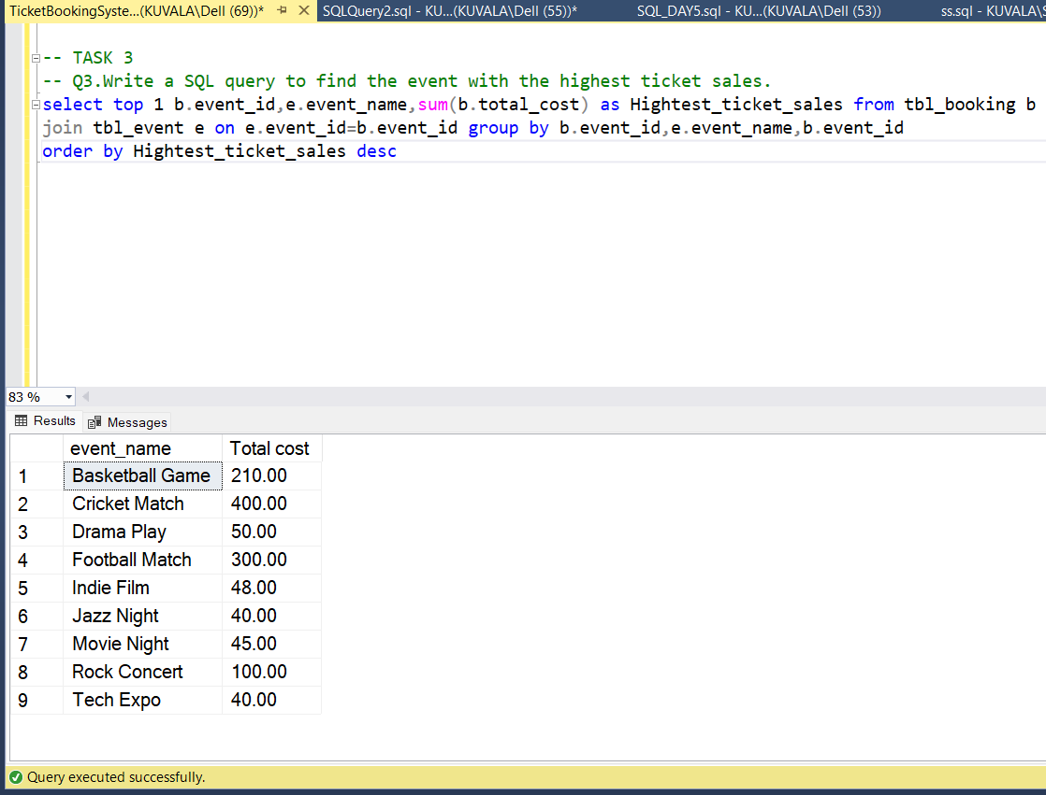

**4.Write a SQL query to Calculate the Total Number of Tickets Sold for Each Event.**

**select e.event_name,sum(b.num_tickets) as "No_of_Tickets_sold" from tbl_booking b**

**join tbl_event e on e.event_id=b.event_id**

**group by e.event_name**

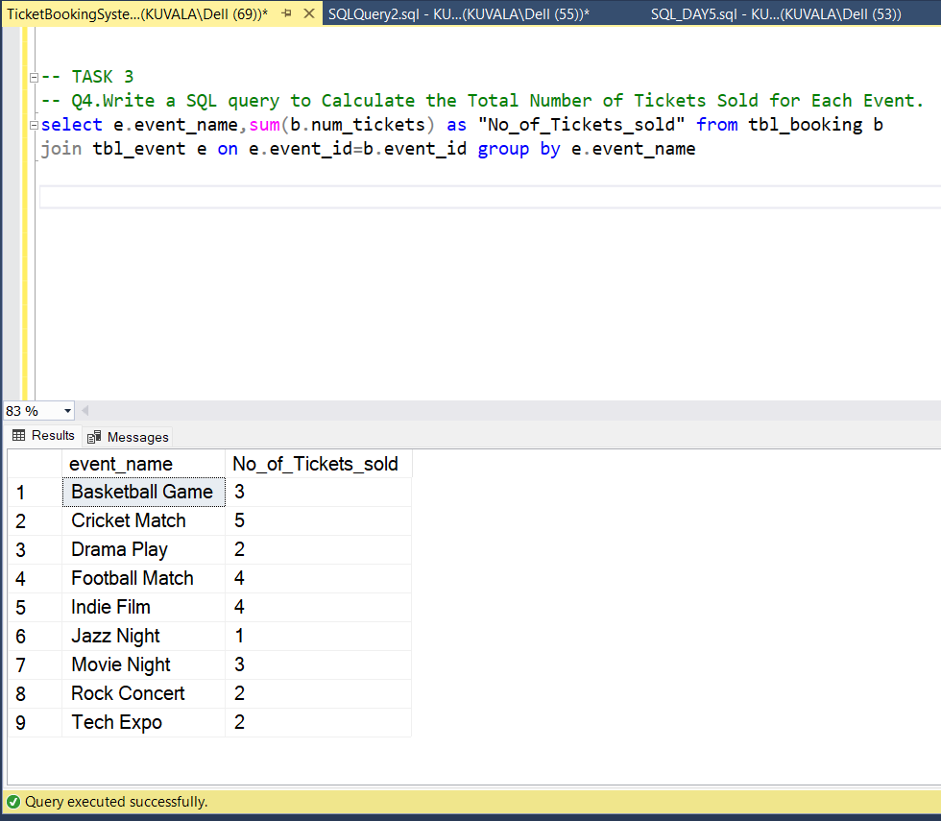

**5.Write a SQL query to Find Events with No Ticket Sales.**

**select e.event_id, e.event_name, e.event_date, e.event_time from tbl_event e**

**left join tbl_booking b on e.event_id = b.event_id where b.booking_id is null**

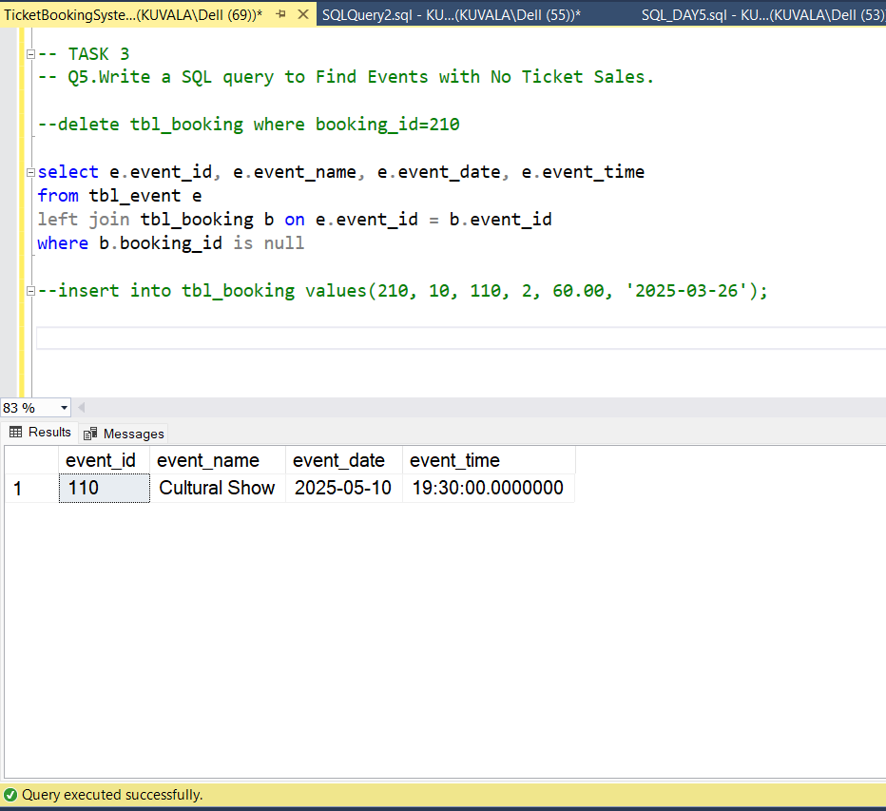

**6. Write a SQL query to Find the User Who Has Booked the Most Tickets.**

**select top 1 c.customer_name,sum(b.num_tickets) as Max_Tickets_Booked from tbl_booking b**

**join tbl_customer c on c.customer_id=b.customer_id group by c.customer_name**

**order by Max_Tickets_Booked desc**

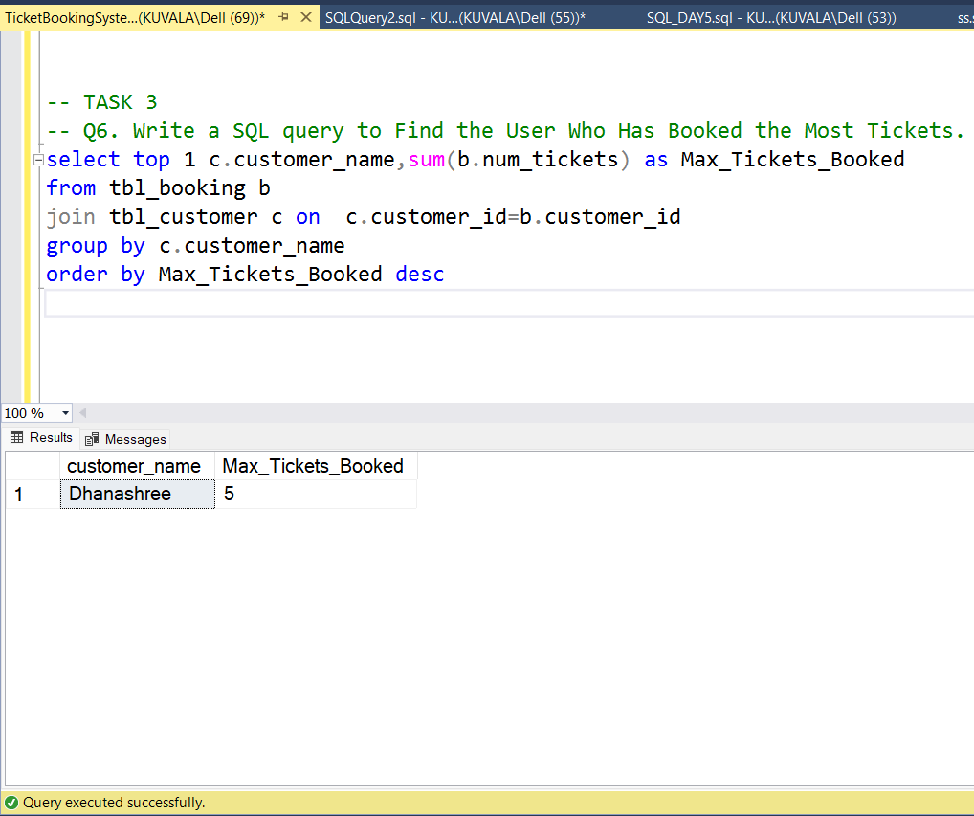

**7.Write a SQL query to List Events and the total number of tickets sold for each month.**

**select e.event_name,month(b.booking_date) as month, sum(b.num_tickets) as total_tickets from tbl_event e**

**join tbl_booking b on e.event_id=b.event_id group by e.event_name,month(b.booking_date)**

**order by month(b.booking_date)**

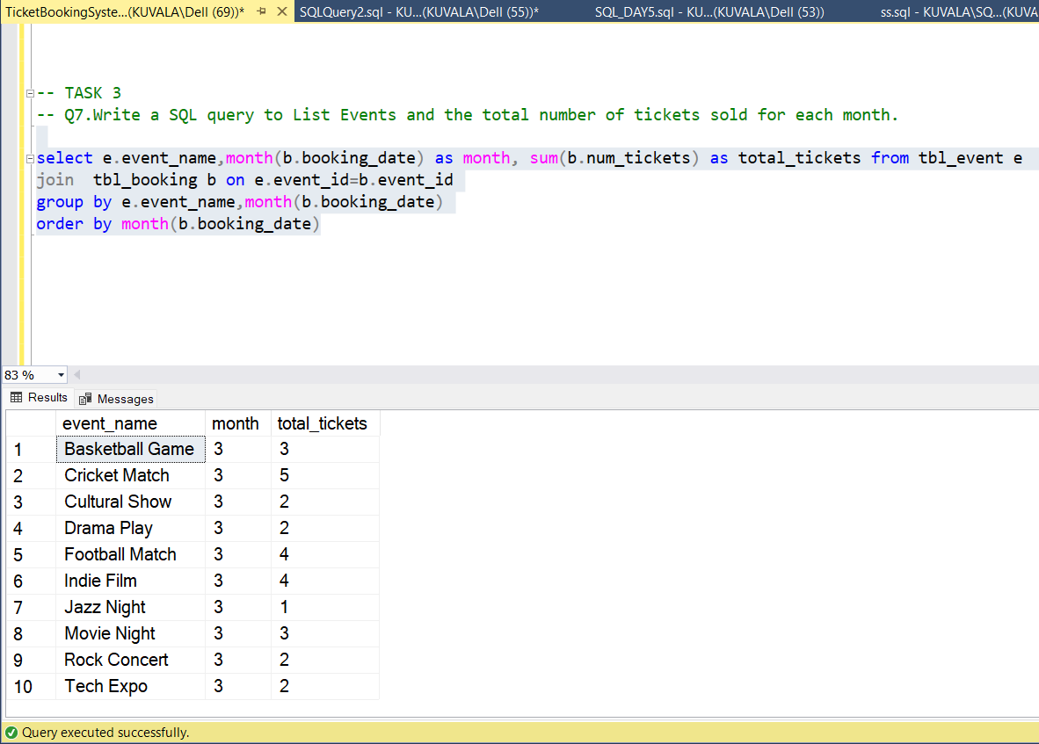

**8.Write a SQL query to calculate the average Ticket Price for Events in Each Venue.**

**select e.venue_id,v.venue_name,avg(e.ticket_price) as 'Average Ticket Price' from tbl_event e**

**join tbl_venue v on v.venue_id=e.venue_id**

**group by e.venue_id,v.venue_name**

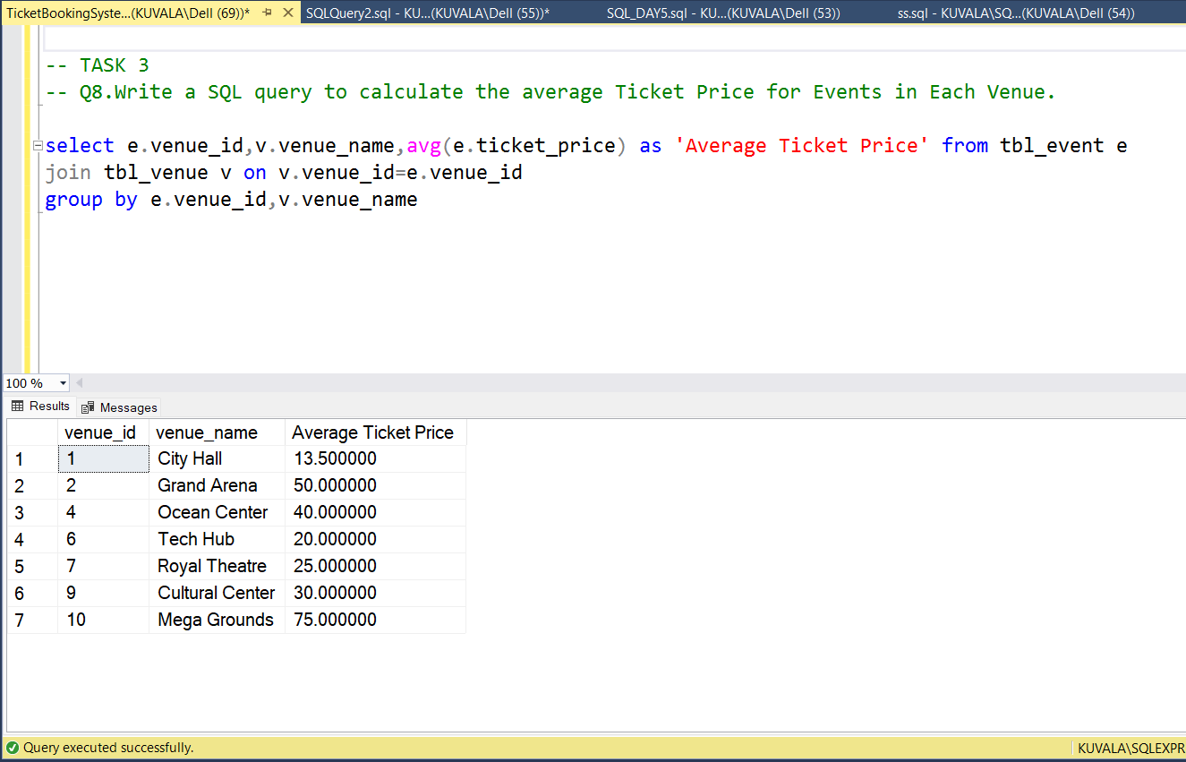

**9.Write a SQL query to calculate the total Number of Tickets Sold for Each Event Type.**

**select e.event_type,sum(b.num_tickets) as"Total Ticket Sold"**

**from tbl_event e join tbl_booking b on b.event_id=e.event_id**

**group by e.event_type**

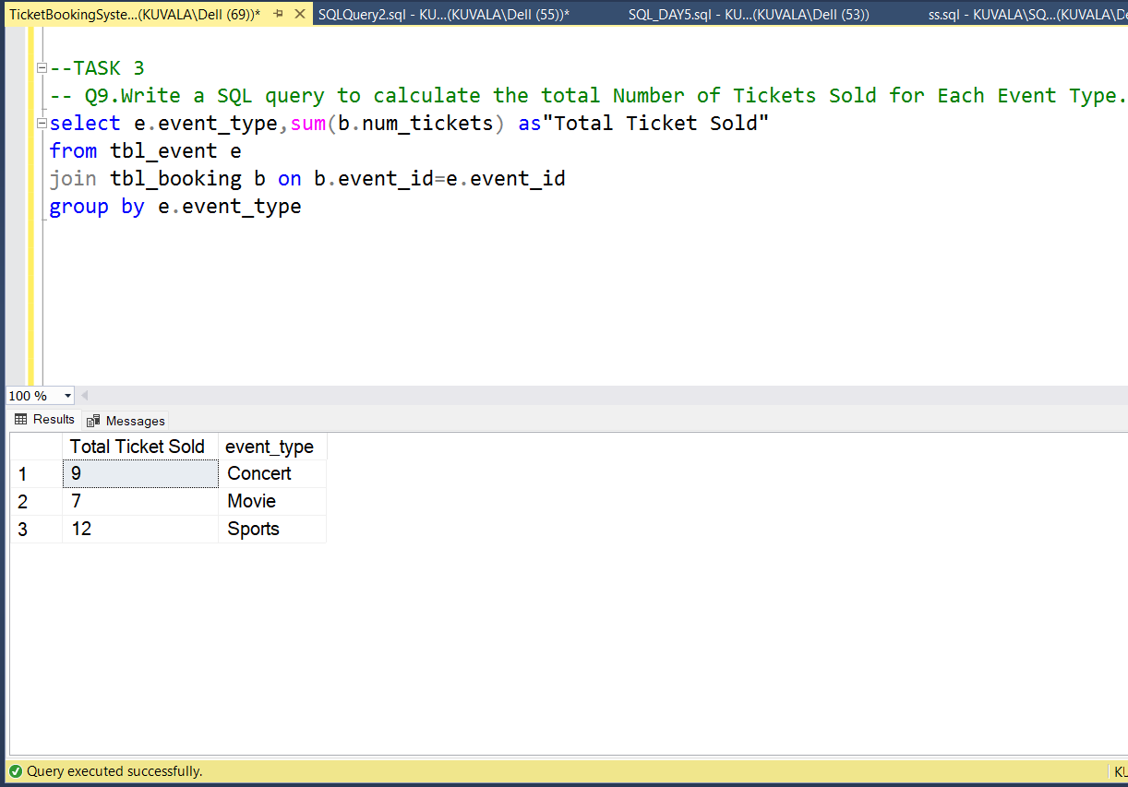

**10. Write a SQL query to calculate the total Revenue Generated by Events in Each Year.**

**select e.event_name,year(b.booking_date) as year, sum(b.num_tickets) as total_tickets from tbl_event e**

**join tbl_booking b on e.event_id=b.event_id**

**group by e.event_name,year(b.booking_date)**

**order by year(b.booking_date)**

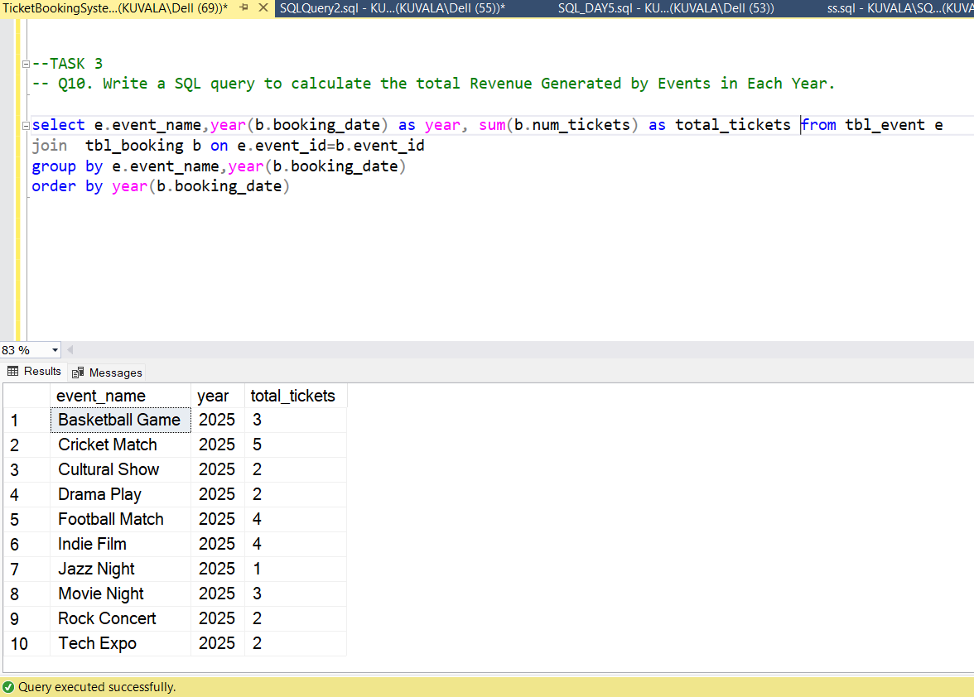

**11. Write a SQL query to list users who have booked tickets for multiple events.**

**select c.customer_id,c.customer_name,count(distinct b.event_id)as Bk_Multi_Events from tbl_customer c**

**join tbl_booking b on b.customer_id=c.customer_id**

**group by c.customer_id,c.customer_name having count(distinct b.event_id)>1;**

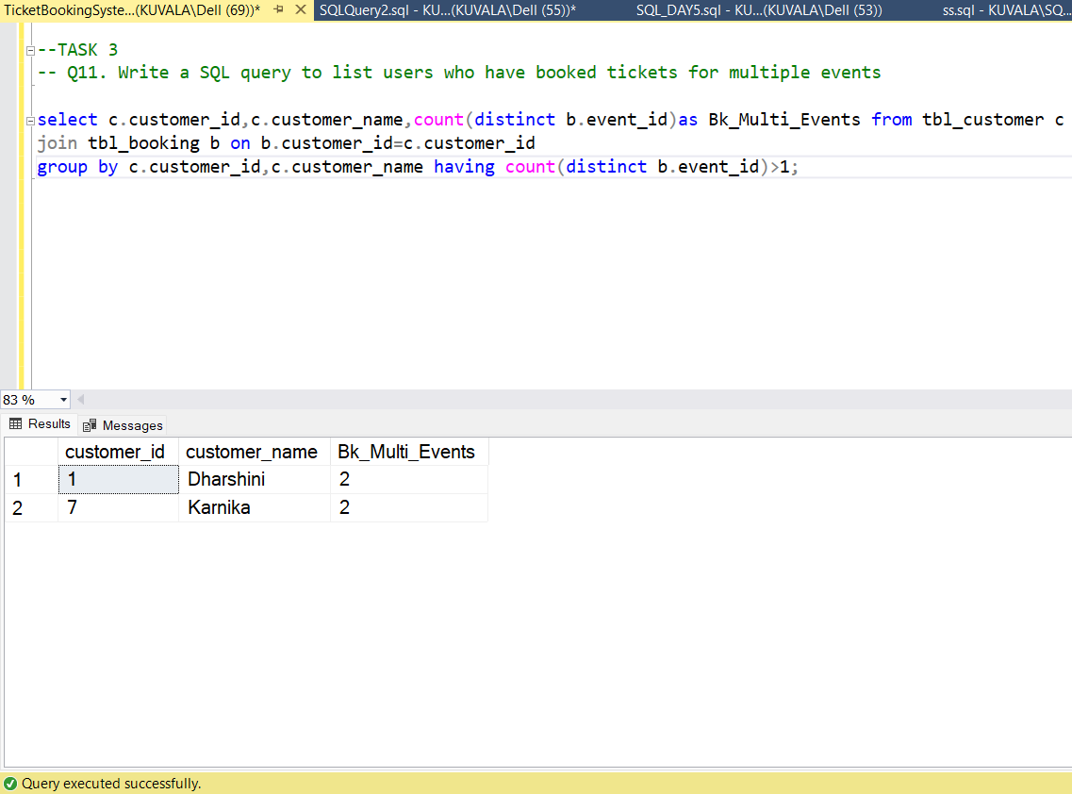

**12.** **Write a SQL query to calculate the Total Revenue Generated by Events for Each User.**

**select c.customer_name,sum(b.total_cost) as "Total cost"**

**from tbl_customer c join tbl_booking b on b.customer_id=c.customer_id**

**group by c.customer_name**

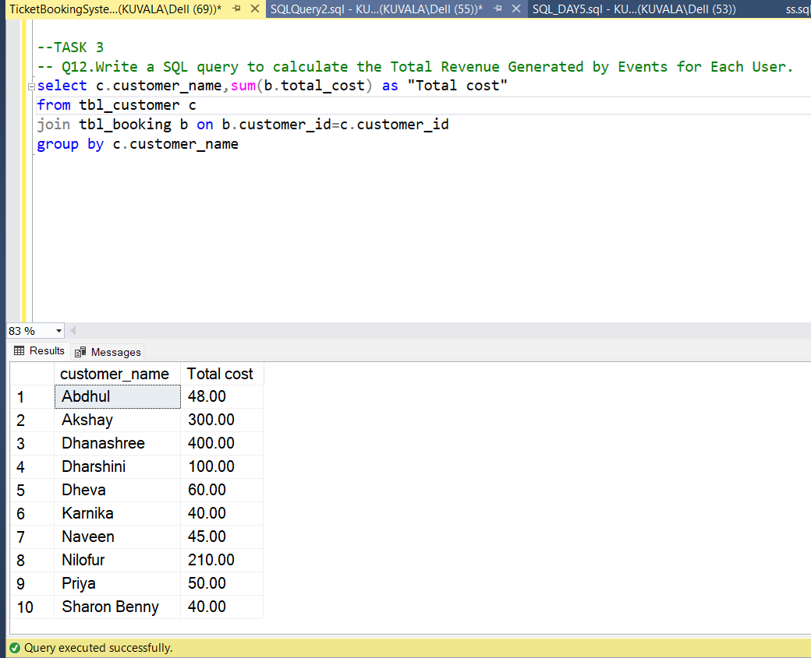

**13. Write a SQL query to calculate the Average Ticket Price for Events in Each Category and Venue.**

**select e.event_type,v.venue_name,avg(e.ticket_price) as "Average Ticket Price" from tbl_event e**

**JOIN tbl_venue v on e.venue_id = v.venue_id**

**group by e.event_type,v.venue_name**

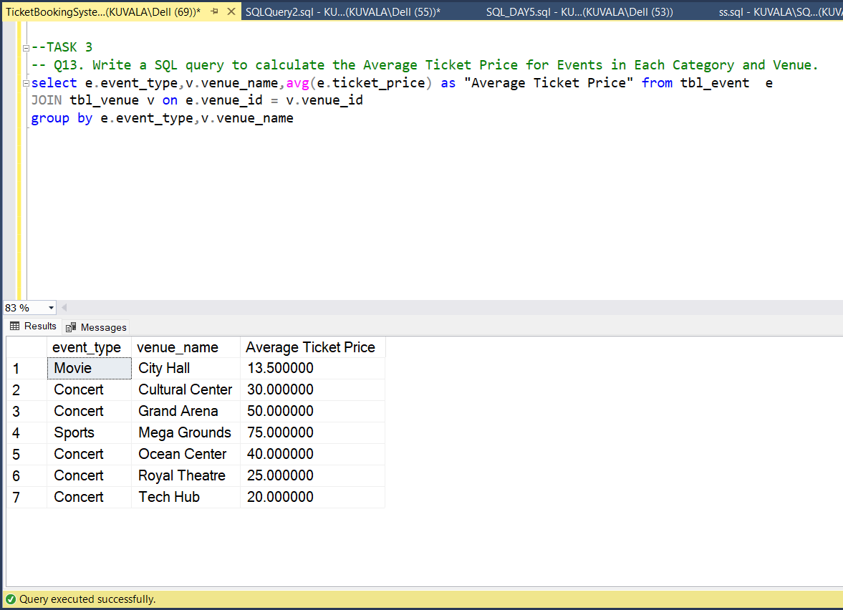

**14. Write a SQL query to list Users and the Total Number of Tickets They've Purchased in the Last 30 Days.**

**select c.customer_name, SUM(b.num_tickets) as "No. of Tickets",b.booking_date**

**from tbl_customer c join tbl_booking b on c.customer_id = b.customer_id**

**where b.booking_date >= DATEADD(day, -30, GETDATE()) group by c.customer_name, b.booking_date;**

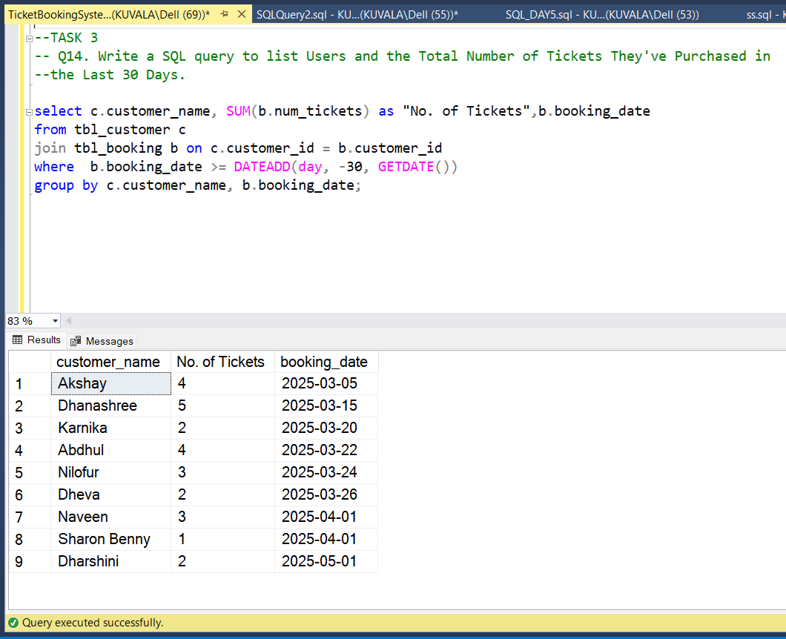

**TASK-4**

**1.Calculate the Average Ticket Price for Events in Each Venue Using a Subquery.**

**select v.venue_id,v.venue_name,**

**(select avg(ticket_price) from tbl_event e where e.venue_id=v.venue_id) as Average_Ticket_Price**

**from tbl_venue v**

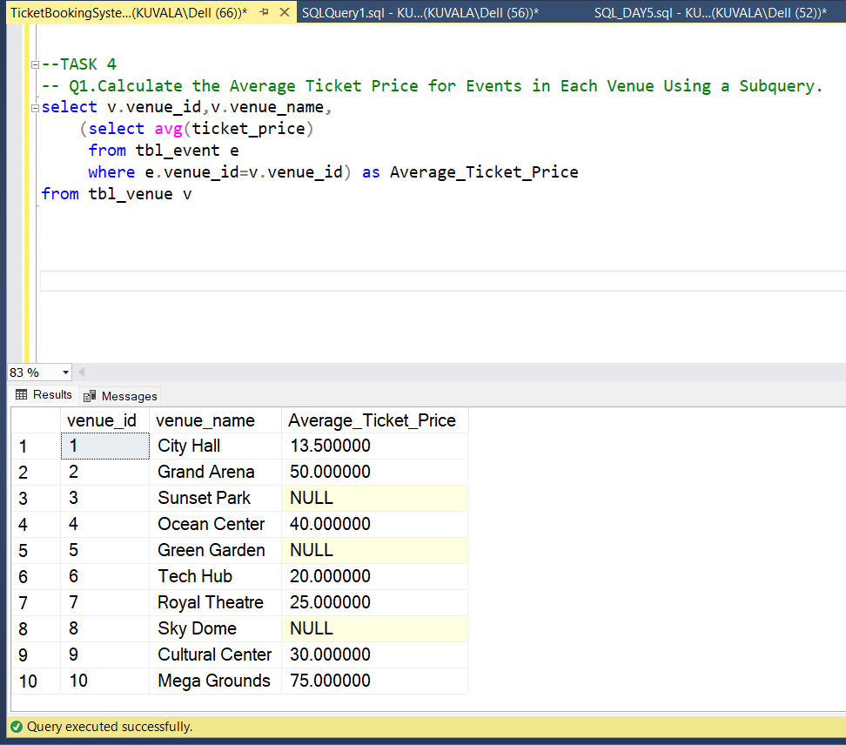

**2. Find Events with More Than 50% of Tickets Sold using subquery.**

**select event_name from tbl_event e**

**where (select total_seats/2 from tbl_event where event_id=e.event_id) > e.available_seats**

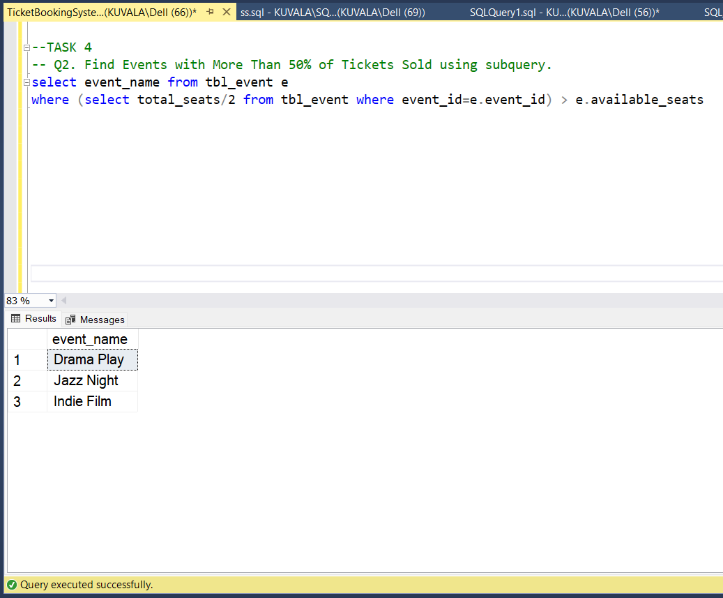

**3. Calculate the Total Number of Tickets Sold for Each Event.**

**select e.event_id,e.event_name,sum(b.num_tickets) as"Tickets sold"**

**from tbl_event e left join tbl_booking b on e.event_id=b.event_id**

**group by e.event_id,e.event_name**

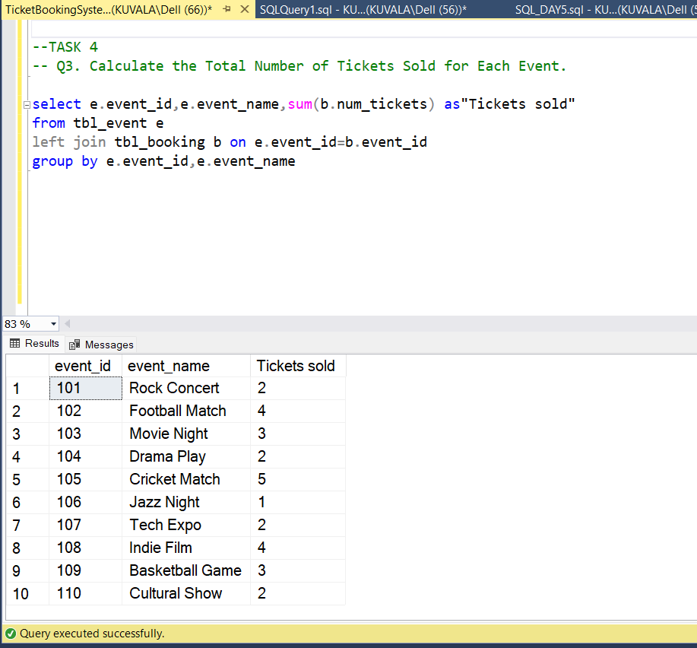

**4. Find Users Who Have Not Booked Any Tickets Using a NOT EXISTS Subquery.**

**select customer_id,customer_name from tbl_customer c**

**where not exists (select 1 from tbl_booking b where b.customer_id=c.customer_id)**

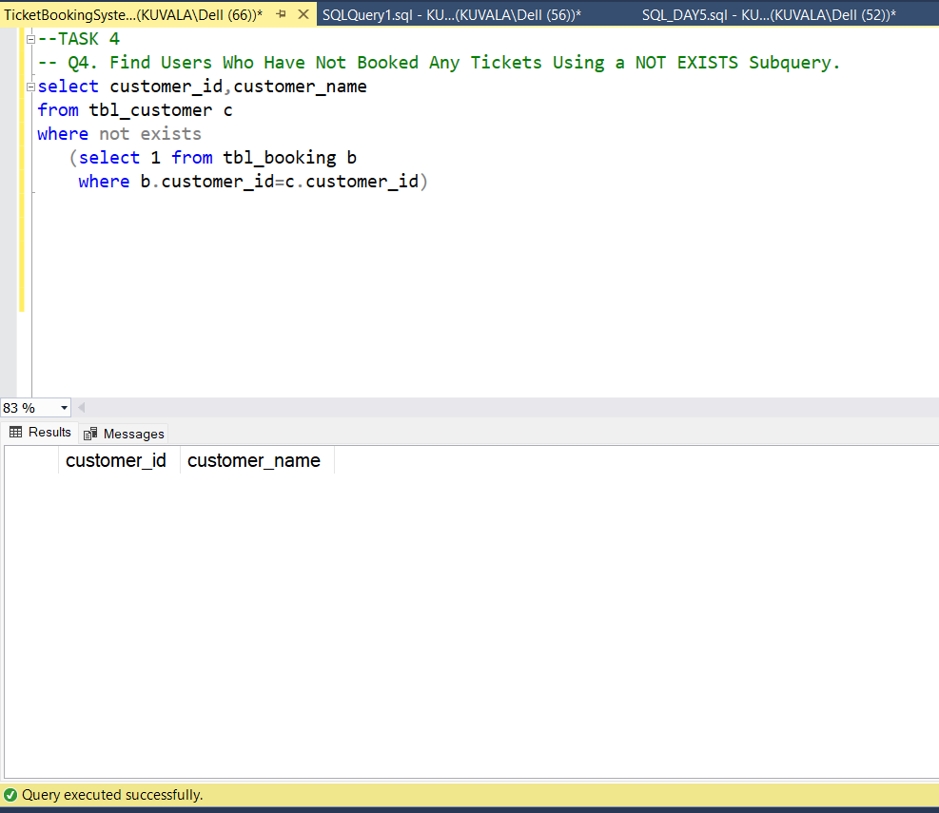

**5. List Events with No Ticket Sales Using a NOT IN Subquery.**

**select e.event_id,e.event_name from tbl_event e**

**where e.event_id not in ( select event_id from tbl_booking)**

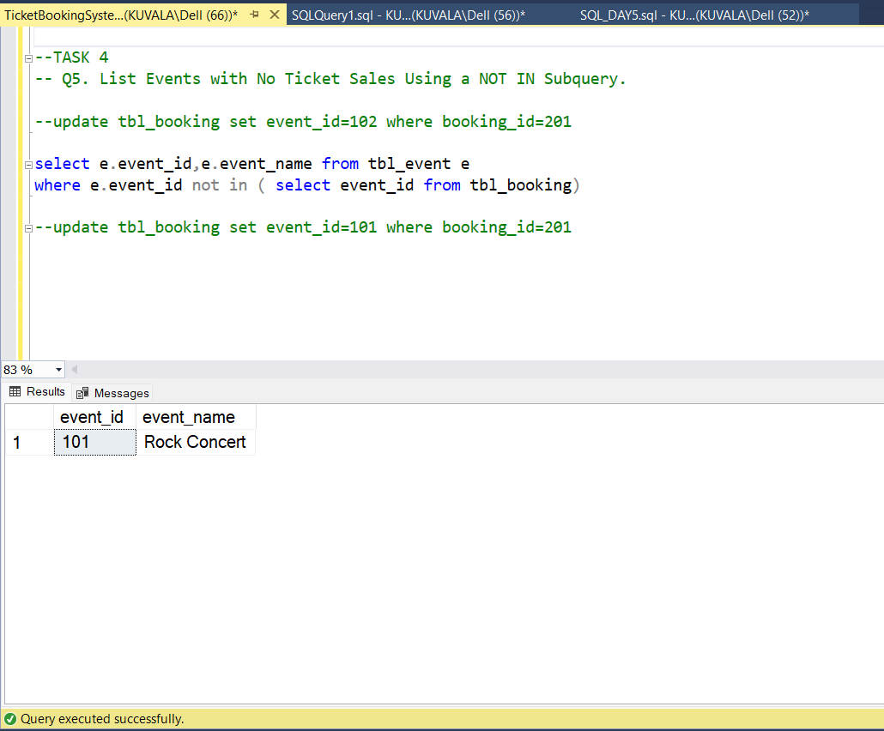

**6.** **Calculate the Total Number of Tickets Sold for Each Event Type Using a Subquery in the FROM Clause.**

**select event_type, sum(Total_Tickets_Sold) as Total_tickets**

**from (select e.event_type, sum(b.num_tickets) as Total_Tickets_Sold**

**from tbl_event e left join tbl_booking b on e.event_id = b.event_id group by e.event_type) as TicketSummary**

**group by event_type**

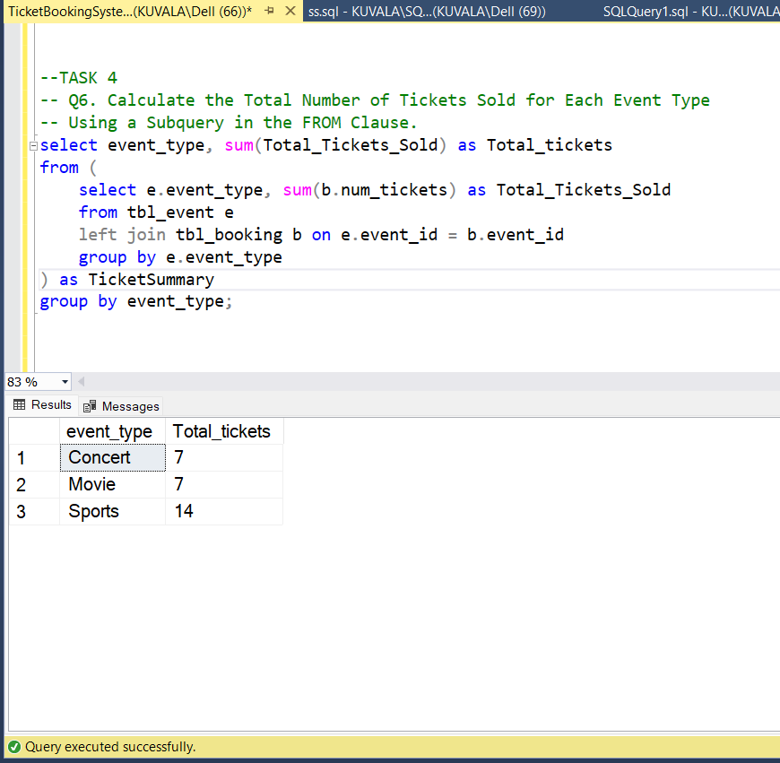

**7. Find Events with Ticket Prices Higher Than the Average Ticket Price Using a Subquery in the WHERE Clause.**

**select e.event_id,e.event_name,e.ticket_price from tbl_event e**

**where e.ticket_price> (select avg(ticket_price) from tbl_event)**

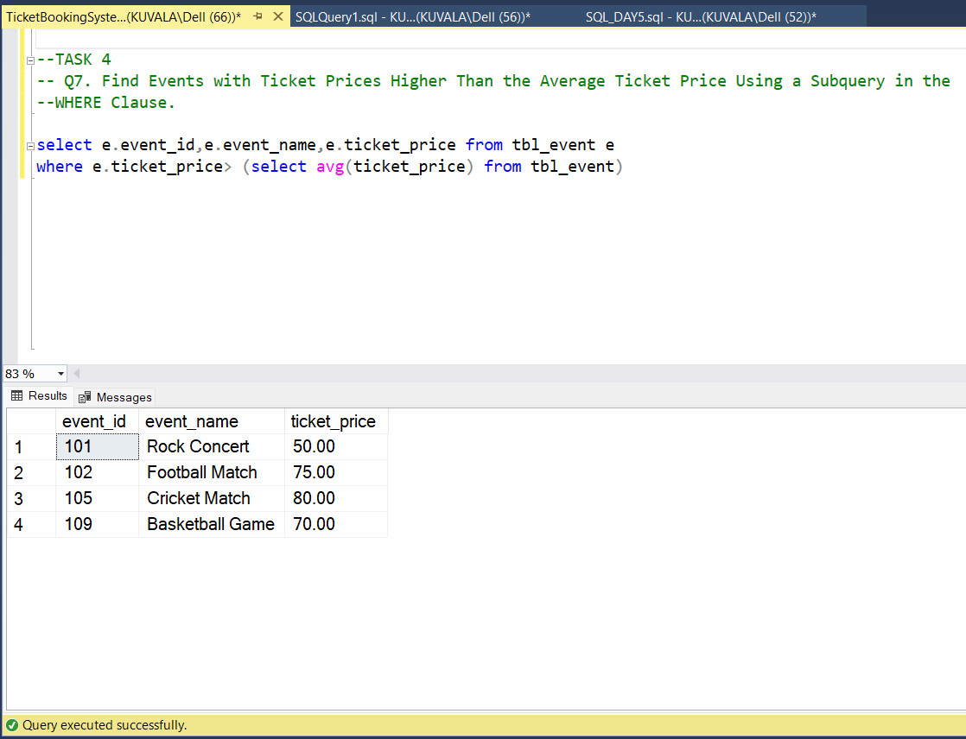

**8.** **Calculate the Total Revenue Generated by Events for Each User Using a Correlated Subquery.**

**select c.customer_id,c.customer_name,**

**(select sum(b.total_cost) from tbl_booking b where b.customer_id=c.customer_id) as 'Total_Revenue'**

**from tbl_customer c**

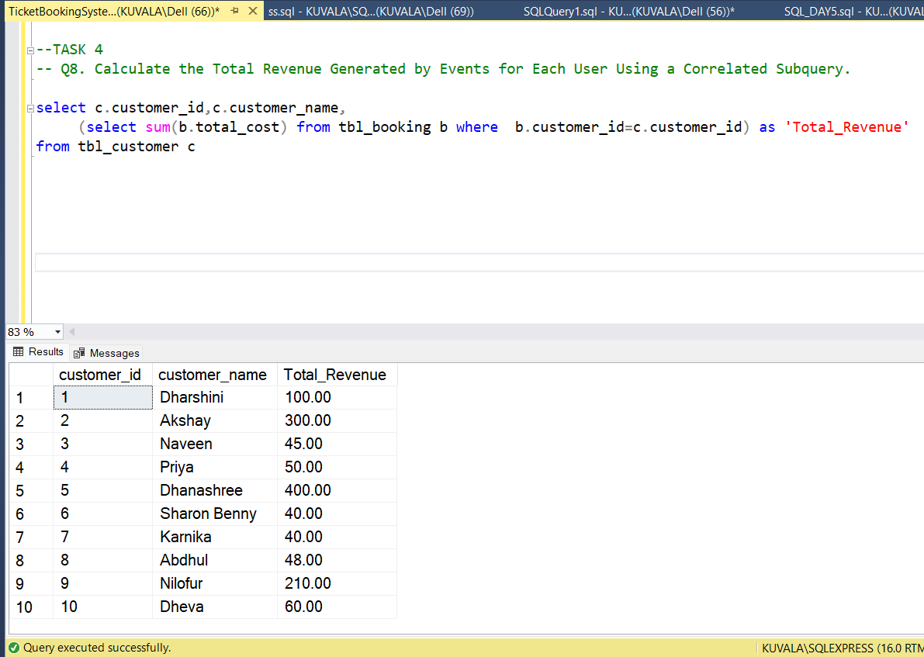

**9. List Users Who Have Booked Tickets for Events in a Given Venue Using a Subquery in the WHERE Clause.**

**select customer_id, customer_name from tbl_customer c**

**where exists ( select 1 from tbl_booking b join tbl_event e on b.event_id = e.event_id**

**where b.customer_id = c.customer_id and e.venue_id = 1)**

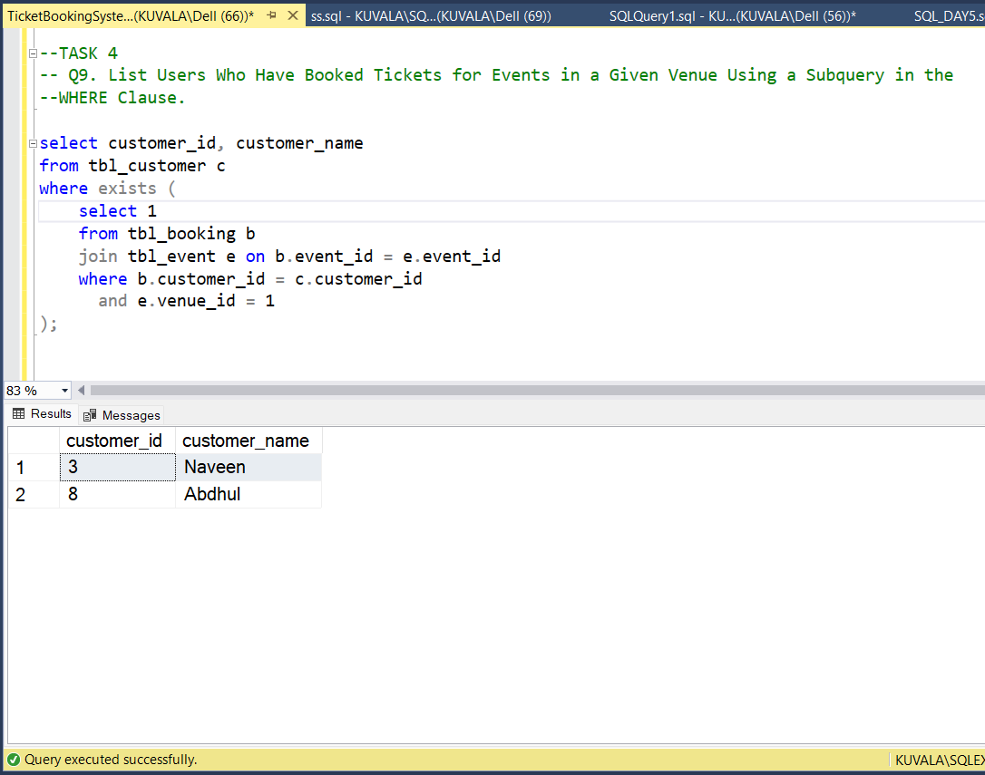

**10. Calculate the Total Number of Tickets Sold for Each Event Category Using a Subquery with GROUP BY.**

**select event_type, SUM(Total_Tickets_Sold) as Total_Tickets**

**from (select e.event_type, SUM(b.num_tickets) as Total_Tickets_Sold from tbl_event e**

**join tbl_booking b on e.event_id = b.event_id**

**group by e.event_type) as tk_summary group by event_type**

